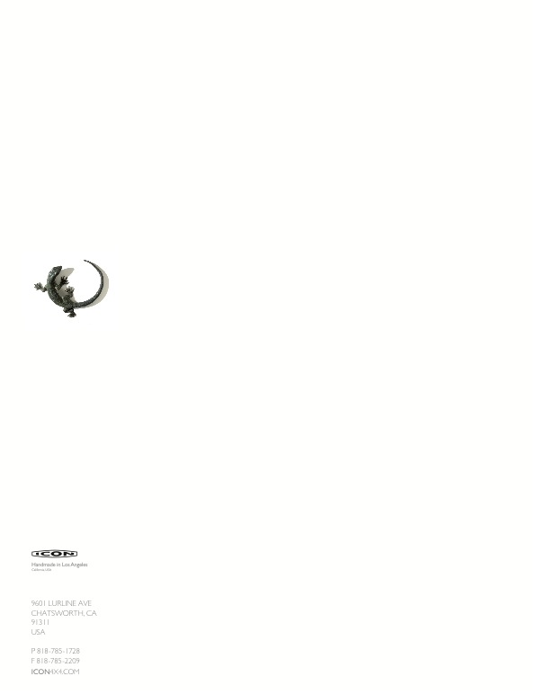

ICON Derelict 1946 Lincoln Club Coupe Details

Hunted and found in Montana, still under the care of the original owner. He was retiring from driving and looking for a new caretaker. All original paint, interior and trim when discovered.

For the Derelict process, ICON removed the body from the original frame, then laser mapped the underside of the body in CAD. The CAD file was then sent to the engineers at our masterful chassis partner company, Art Morrison Enterprises. AME was then tasked with engineering frame rails that would interface with the body, while ICON worked on power train engineering and design details.

After consulting the client to better determine his style and needs, we chose the 2013 Mustang GT 5.0 Coyote fuel injected V8, with a Ford automatic. Independent suspension (Tubular TIG welded) up front, four link rear, JRE race shocks (coil-over’s). Mandrel bent, ceramic coated, stainless exhaust system. Stainless steel fuel tank with in tank pump and sump.

An iPhone/iPod dependent audio system with four hidden Focal Audio speakers and bass was designed to function through the original AM radio. The stock volume knob runs system volume, while the tune knob adjusts bass volume. A modern A/C system was fit in dash, with the original dash speaker vent repurposed to function as the primary A/C vents. Two more A/C vents at the outer edges of the cabin are hidden under dash. A custom steering column was fit that allows use of the beautiful original steering wheel, while the stock manual “three on the tree” shifter now controls the modern automatic through a cable system. All stock gauges were modified internally with all modern VDO units, while we kept the stock needles and weathered face art intact. All stock switch knobs have been maintained, yet run modern switched behind the scenes.

The interior panel designs are based on the original, yet redone in custom weathered leather. The interesting deco embossed texture on the seats and door panels were created by steaming then running the finished hides through a CNC’er roller, which imprints the pattern onto the hide. All bright work in the interior is original, simply cleaned. The original Bakelite power window switches now control modern electric power windows. All glass, with the exception of the windshield, is original.