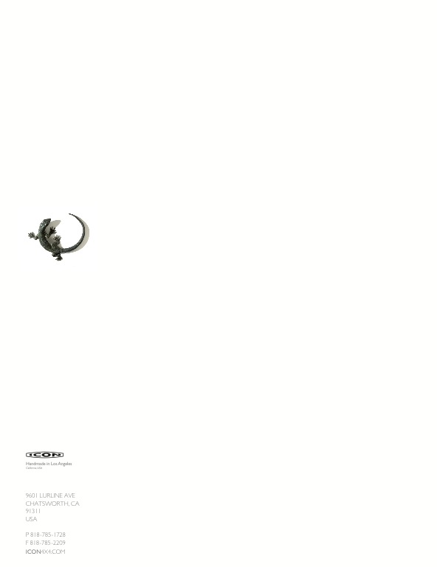

October 23, 2013

ICON is proud to release the next one-off vehicle in the ICON Derelict line, the 1946 Lincoln Club Coupe Derelict. ICON is a niche automotive brand focused on revisiting vintage transportation in a modern context. While we have a series of “production” models based on the classic Willys CJ3B, Toyota Land Cruisers and Ford Bronco, we also do custom builds in our Derelict & Reformer series. Each is a one of a kind build, commissioned by a client. The ICON Reformers feature modern technology and drivability mated with a restored and restyled classic body. The ICON Derelicts celebrate time earned patina and a greater nostalgic sense of time by featuring as-found vintage bodies with original trim and paint, hiding modern mechanical underpinnings and details.

This ICON 1946 Lincoln Club Coupe Derelict was purchased in Montana from the original owner. We liberated the original body from the stock chassis, laser scanned the underside of the body, and set out to engineer a modern chassis with Art Morrision Enterprises (the chassis partner on almost all ICON projects).

The beauty in these projects is in the details. The wonderful patina finish is complemented by a custom embossed green leather interior, with Rolls Royce Wilton wool carpets (hemmed in leather), with a headliner made from new-old-stock mohair. The stock steering wheel is cleverly mounted to a collapsible stainless steel steering column, with the shifter designed by matching modern linkage solutions with the original three-speed shifter arm and Bakelite knob. The stock AM radio now controls a WiFi enabled iPhone-iPod based modern system with Focal speakers and bass. The stock AM radio dash speaker has been repurposed to function as vents for the hidden modern A/C system. The stock Bakelite and stainless power window switches now run modern 12 volt power windows. The wheels and CNC’ed, powder coated billet with ZR rated BF Goodrich G-Force tires. The underside of the body is coated in heat cured Polyurea, while the inside surfaces of the body and doors are coated in Dynamat.

Designed to be safe, versatile and highly functional, this ICON Derelict was built to be driven. The owner is a repeat ICON client and SoCal resident.

ICON Classic styling, modern engineering, timeless utility!

Highlights- *Art Morrison .180” wall mandrel bent 2x5 rails*

*Tubular independent front suspension*

*Four link rear (Currie 9” with Strange axles)*

*20:1 power rack & pinion*

*Wilwood four wheel ABS disc brakes (6 piston front, 4 piston rear)*

*22 gallon stainless fuel tank with in-tank f/I pump*

*All systems stainless plumbed*

*3” mandrel bent, ceramic coated exhaust*

*Hand built (Painless Performance based) wiring harness*

Vintage Air GENIV HVAC system

All LED lighting (H4 headlights)

Gauges & controls appear stock, hiding modern functions and precision electronics

Custom ICON designed embossed leather seating

PR Contact On Site ICON Contact

Dan Weikel Jonathan Ward (CEO)

IBP Media Mobile: 818-232-1923

Mobile: 818-324-3857 jw@icon4x4.com

[dweikel@ibpmedia.com](mailto:dweikel@ibpmedia.com) iconcustoms.com

[www.ibpmedia.com](http://www.ibpmedia.com/)